**SOFTWARE REQUIREMENT SPECIFICATION** **DOCUMENT**

**CALCULATE WITH ME SYSTEM**

**Version:** 2.1

**ABSTRACT**

This document is intended to be the SRS for developing **CALCULATE WITH ME SYSTEM**

|  |  |  |  |
| --- | --- | --- | --- |
| **Project Title** | **CALCULATE WITH ME SYSTEM** | | |
| **Lead Institution** | **INTERNATIONAL SCHOOL - DUY TAN UNIVERSITY** | | |
| **Project Mentor** | **Mr. Nguyen Dang Quang Huy** | | |
| **Team Name** | **TEAM 6** | | |
| **Team Members** | **Le Phan Nhat Linh** | | |
| **Hoang Thi Thanh Nhan** | | |
| **Le Truong Huy** | | |
| **Do Tuan Kiet** | | |
|  | | |
| **Start Date** | February 26, 2024 | **End Date** | January 4, 2024 |

**PROPRIETARY INFORMATION**: The information contained in this document is the property of **TEAM 6**. Except as specifically authorized in writing by **TEAM 6**, the holder of this document shall keep all information contained herein confidential and shall protect same in whole or in part from disclosure and dissemination to all third parties

**Table of Contents**

Revision History 3

1. Introduction 4

1.1. Purpose 4

1.2. Intended Audience and Suggested Reading 4

1.3. References 4

2. Project Overview 4

2.1. Project Description 4

2.2. Business Need 4

2.3. Project Analyst 5

2.3.1. Business Function Diagram 5

2.3.2. System Context Diagram 5

2.4. Software Requirement Specification 6

2.4.1. High-level Functional Requirement (FR) 6

2.4.2. Stakeholders 6

2.4.3. Use case 6

UC 01: Addition 7

UC.02: Subtraction 8

UC.03: Multiplication 9

UC.04: Div 10

UC.05: Mod 11

UC.06: AC 12

2.4.6. Activity Diagrams 13

2.4.6.1 Addition 13

2.4.6.2 Subtraction 14

2.4.6.3 Multiplication 15

2.4.6.4 Div 16

2.4.6.5 Mod 17

2.4.6.6 AC 18

# Revision History

|  |  |  |  |  |
| --- | --- | --- | --- | --- |
| **Date** | **Change item** | **Description** | **by** | **Version** |
| **22/1/2024** | Receive requests from customers | After preparing questions about the request and receiving requests from customers | All members | Version 1.0 |
| **23/1/2024** | Start team meeting | Meet and refer to some documents, then focus on implementing the project. The team can fully understand the system requirements after the meeting | All members | Version 1.0 |
| **23/1/2024** | Work analysis | Through specific requirements and analysis, speaking, the leader needs to prepare in advance for the members. | All members | Version 1.0 |
| **23/1/2024** | Assign work | Get BFD, context diagram, use case, use case specification, and activity diagrams. The mandatory rules of the project | Le Phan Nhat Linh | Version 1.0 |
| **23/1/2024** | Conduct the work | Team members complete the tasks assigned by the team leader. And submit the report on time to the team leader | All members | Version 1.0 |
| **24/1/2024** | Edit the report | The group leader receives reports from group members, then reviews and revises them as required | Le Phan Nhat Linh | Version 1.0 |
| **25/2/2024** | Complete the SRS file | Complete BFD, context diagram, use case, use case specification, and activity diagrams. | All members | Version 2.0 |
|  |  |  |  |  |

# Introduction

## Purpose

This document describes a computer system that includes all the basic calculations, and it details the implementation. The purpose of this document is as follows:

* Support project managers to have an overview of the system as well as prepare project estimates
* To describe use cases in detail. Based on this documentation, architectural analysts and designers will be able to implement the system with ease.
* Support testers (QCs) in writing acceptance tests and test plans.

## Intended Audience and Suggested Reading

|  |  |
| --- | --- |
| Intended Audience | Suggested Reading |
| Project manager | High-level functional requirements, business constraints to estimate |
| Architect analyst and designer | Overall description and user cases for system architecture and design |
| Quality control | Overall description and user cases for planning tests and writing acceptance tests |

## References

# Project Overview

## Project Description

Information technology has revolutionized people's lives and made life easier thanks to various types of applications. In view of the rapid changes in the use of Information Technology, there are many tools, technologies, and systems that have been produced and invented.

This project involves developing a basic computer system to help people calculate faster and get more accurate results. The goal of this project is to bring simplicity, safety, and efficiency while reducing unnecessary computing time.

## Business Need

This system has a number of advantages:

- Support accountants in professional tasks such as invoice management and calculations when working on projects

- Support students to calculate faster while studying

- Safe, friendly, easy-to-use interface.

## Project Analyst

### Business Function Diagram

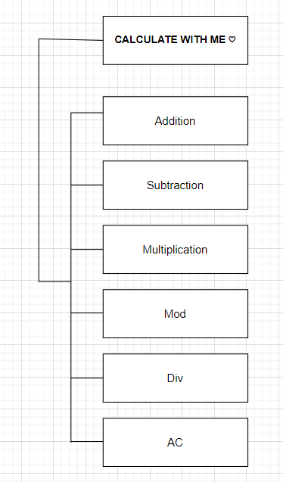

### System Context Diagram

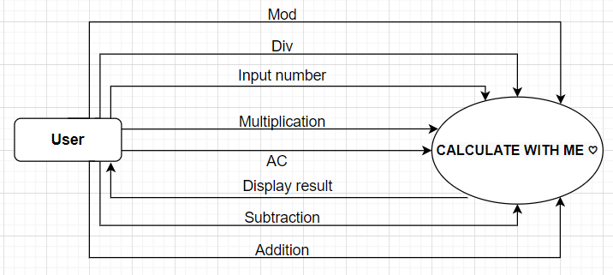

## Software Requirement Specification

### High-level Functional Requirement (FR)

|  |  |  |
| --- | --- | --- |
| FR1.1 | **Title** | **Calculate** |
| Math | User uses the system to calculate any two numbers |
| Description | The system displays the calculation interface including Entering any 2 numbers, performing the following math operations: +, -, *, /, % for the 2 entered numbers and displaying the results on the form, end-use |

### Stakeholders

|  |  |
| --- | --- |
| **Stakeholder** | **Description** |
| Users | System users |

### 2.4.3. Use case

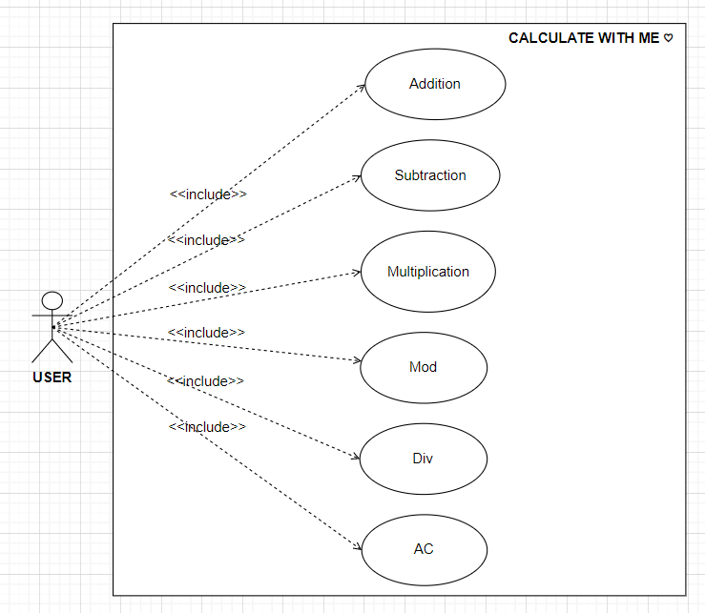

**2.4.4. List of use case**

|  |  |  |
| --- | --- | --- |
| **Use case ID** | **Use case name** | **Functional Req.** |
| UC.01 | Addition | FR.1 |
| UC.02 | Subtraction | FR.2 |
| UC.03 | Multiplication | FR.3 |
| UC.04 | Mod | FR.4 |
| UC.05 | Div | FR.5 |
| UC.06 | AC | FR.6 |

**2.4.5. Use Case Specification**

##### UC 01: Addition

1. Use Case Diagram

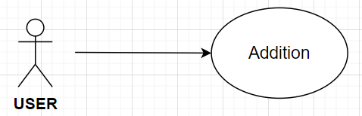

1. Use Case Specification

|  |  |  |  |  |  |
| --- | --- | --- | --- | --- | --- |
|  | UC.02 | | | | |
| Use case name | Addition | | | | |
| Create by | Thanh Nhan | | **Last updated by** | | Thanh Nhan |
| Date created | Jan 23, 2024 | | **Date last updated** | | Jan 24, 2024 |
| Actor | User | |  | | |
| Description | This use case allows the user to perform an arithmetic "+" operation. | | | | |
| Trigger | Click + to enable the feature. | | | | |
| Pre-condition | Enter any two numbers to perform the calculation | | | | |
| Post-condition | Users will receive results if they enter the correct numbers (not words). | | | | |
| Main Success Scenario | **Step** | **Actor Action** | | **System Response** | |
| 1 | Enter information in the "First Number" box and "Second Number" box. | |  | |
| 3 | Click the + button | | Execute the results and print them in the "Result" box. | |
| Alternative Scenario | **Step** | **Actor Action** | | **System Response** | |
| 1 | Enter information in the "First Number" box and "Second Number" box. | |  | |
| 2 | Click the + button | | If First Number or Second number is not a number, Display the error message "For input string: "(wrong input content)" | |
| Priority | High | | | | |
| Business rule |  | | | | |
| Description: | After entering numbers into the "First number" and "Second number" boxes, the user will select the function to calculate, the system will display the results if the correct information (Number) is entered. If you enter incorrect information (word), an error will be reported. | | | | |

##### UC.02: Subtraction

1. Use Case Diagram   
   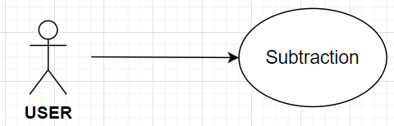
2. Use Case Specification

|  |  |  |  |  |  |
| --- | --- | --- | --- | --- | --- |
| Use case ID | UC.02 | | | | |
| Use case name | Subtraction | | | | |
| Create by | Thanh Nhan | | **Last updated by** | | Thanh Nhan |
| Date created | Jan 23, 2024 | | **Date last updated** | | Jan 24, 2024 |
| Actor | User | |  | | |
| Description | This use case allows the user to perform an arithmetic "-" operation. | | | | |
| Trigger | Click - to enable the feature. | | | | |
| Pre-condition | Enter any two numbers to perform the calculation | | | | |
| Post-condition | Users will receive results if they enter the correct numbers (not words). | | | | |
| Main Success Scenario | **Step** | **Actor Action** | | **System Response** | |
| 1 | Enter information in the "First Number" box and "Second Number" box. | |  | |
| 2 | Click the - button | | Execute the results and print them in the "Result" box. | |
| Alternative Scenario | **Step** | **Actor Action** | | **System Response** | |
| 1 | Enter information in the "First Number" box and "Second Number" box. | |  | |
| 2 | Click the - button | | If the First Number or Second number is not a number, Display the error message "For input string: "(wrong input content)" | |
| Priority | High | | | | |
| Business rule |  | | | | |
| Description: | After entering numbers into the "First number" and "Second number" boxes, the user will select the function to calculate, the system will display the results if the correct information (Number) is entered. If you enter incorrect information (word), an error will be reported. | | | | |

##### UC.03: Multiplication

1. Use Case Diagram   
   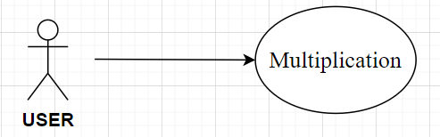
2. Use Case Specification

|  |  |  |  |  |  |
| --- | --- | --- | --- | --- | --- |
| Use case ID | UC.02 | | | | |
| Use case name | Multiplication | | | | |
| Create by | Nhat Linh | | **Last updated by** | | Nhat Linh |
| Date created | Jan 23, 2024 | | **Date last updated** | | Jan 24, 2024 |
| Actor | User | |  | | |
| Description | This use case allows the user to perform an arithmetic "*" operation. | | | | |
| Trigger | Click * to enable the feature. | | | | |
| Pre-condition | Enter any two numbers to perform the calculation | | | | |
| Post-condition | Users will receive results if they enter the correct numbers (not words). | | | | |
| Main Success Scenario | **Step** | **Actor Action** | | **System Response** | |
| 1 | Enter information in the "First Number" box and "Second Number" box. | |  | |
| 2 | Click the * button | | Execute the results and print them in the "Result" box. | |
| Alternative Scenario | **Step** | **Actor Action** | | **System Response** | |
| 1 | Enter information in the "First Number" box and "Second Number" box. | |  | |
| 2 | Click the * button | | If the First Number or Second number is not a number, Display the error message “For input string: "Wrong input content" | |
| Priority | High | | | | |
| Business rule |  | | | | |
| Description: | After entering numbers into the "First number" and "Second number" boxes, the user will select the function to calculate, the system will display the results if the correct information (Number) is entered. If you enter incorrect information (word), an error will be reported. | | | | |

##### UC.04: Div

1. Use Case Diagram   
   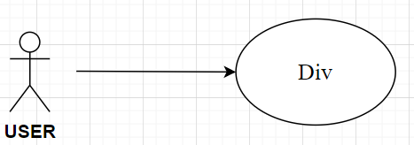
2. Use Case Specification

|  |  |  |  |  |  |
| --- | --- | --- | --- | --- | --- |
|  | UC.02 | | | | |
| Use case name | Divide the whole. | | | | |
| Create by | Truong Huy | | **Last updated by** | | Truong Huy |
| Date created | Jan 23, 2024 | | **Date last updated** | | Jan 24, 2024 |
| Actor | User | |  | | |
| Description | This use case allows the user to perform an arithmetic "/" operation. | | | | |
| Trigger | Click / to enable the feature. | | | | |
| Pre-condition | Enter any two numbers to perform the calculation | | | | |
| Post-condition | Users will receive results if they enter the correct numbers (not words). | | | | |
| Main Success Scenario: | **Step** | **Actor Action** | | **System Response** | |
| 1 | Enter information in the "First Number" box and "Second Number" box. | |  | |
| 2 | User enters book title to search | |  | |
| 3 | Click the / button | | Check, execute the results, and print them in the "Result" box. | |
| Exceptions | **Step** | **Actor Action** | | **System Response** | |
| 1 | The information entered is not a number | | Display the error message “For input string: "Wrong input content"” | |
| 2 | Divide by 0 | | Displays the error table "/by zero/" | |
| Priority | High | | | | |
| Business rule |  | | | | |
| Description: | After entering numbers into the "First number" and "Second number" boxes, the user will select the function to calculate, the system will display the results if the correct information (Number) is entered. If you enter incorrect information (word), an error will be reported. | | | | |

##### UC.05: Mod

1. Use Case Diagram   
   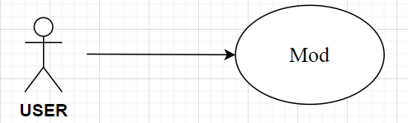
2. Use Case Specification

|  |  |  |  |  |  |
| --- | --- | --- | --- | --- | --- |
| Use case ID | UC.02 | | | | |
| Use case name | Divide sign for residual. | | | | |
| Create by | Truong Huy | | **Last updated by** | | Truong Huy |
| Date created | Jan 23, 2024 | | **Date last updated** | | Jan 24, 2024 |
| Actor | User | |  | | |
| Description | This use case allows the user to perform an arithmetic "%" operation. | | | | |
| Trigger | Click % to enable the feature. | | | | |
| Pre-condition | Enter any two numbers to perform the calculation | | | | |
| Post-condition | Users will receive results if they enter the correct numbers (not words). | | | | |
| Main Success Scenario: | **Step** | **Actor Action** | | **System Response** | |
| 1 | Enter information in the "First Number" box and "Second Number" box. | |  | |
| 2 | User enters the book title to search | |  | |
| 3 | Click the % button | | Check, execute the results and print them in the "Result" box. | |
| Exceptions | **Step** | **Actor Action** | | **System Response** | |
| 1 | The information entered is not a number | | Display the error message “For input string: "Wrong input content" | |
| 2 | Divide by 0 | | Displays the error table "/by zero/" | |
| Priority | High | | | | |
| Business rule |  | | | | |
| Description: | After entering numbers into the "First number" and "Second number" boxes, the user will select the function to calculate, the system will display the results if the correct information (Number) is entered. If you enter incorrect information (word), an error will be reported. | | | | |

##### UC.06: AC

1. Use Case Diagram   
   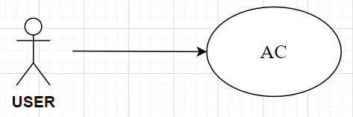
2. Use Case Specification

|  |  |  |  |  |  |
| --- | --- | --- | --- | --- | --- |
| Use case ID | UC.02 | | | | |
| Use case name | AC | | | | |
| Create by | Tuan Kiet | | **Last updated by** | | Tuan Kiet |
| Date created | Jan 23, 2024 | | **Date last updated** | | Jan 24, 2024 |
| Actor | User | |  | | |
| Description | This use case allows the user to perform an "AC" or reset operation. | | | | |
| Trigger | Click “AC” to enable the feature. | | | | |
| Pre-condition | Data entry may or may not be available. | | | | |
| Post-condition | The user can input new data. | | | | |
| Main Success Scenario: | **Step** | **Actor Action** | | **System Response** | |
| 1 | Click the “AC” button | |  | |
|  |  | | Reset full | |
| Alternative Scenario | **Step** | **Actor Action** | | **System Response** | |
|  |  | |  | |
|  |  | |  | |
| Priority | High | | | | |
| Business rule |  | | | | |
| Description: | To perform a new calculation, the user must click AC in the condition where the data was previously entered. If no data has been previously entered, it is not necessary to select AC to perform a new calculation. | | | | |

## 2.4.6. Activity Diagrams

## 2.4.6.1 Addition

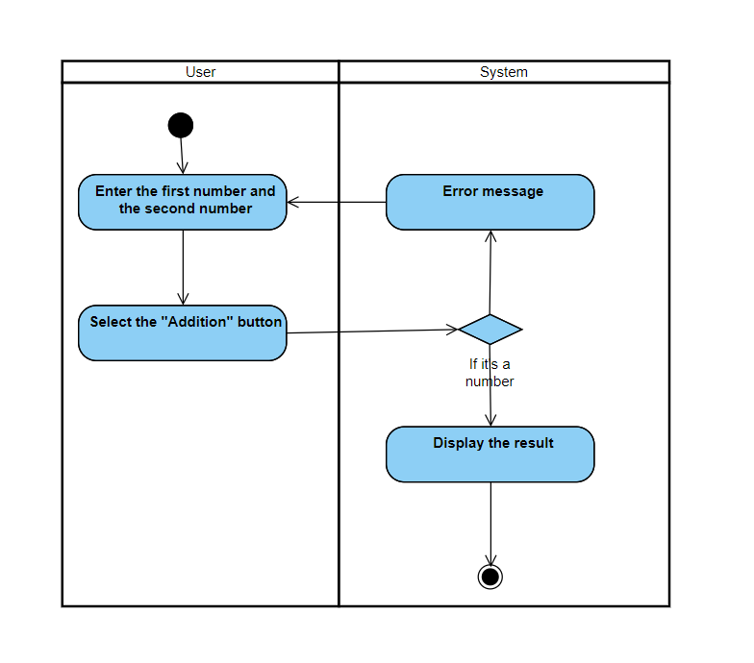

## 2.4.6.2 Subtraction

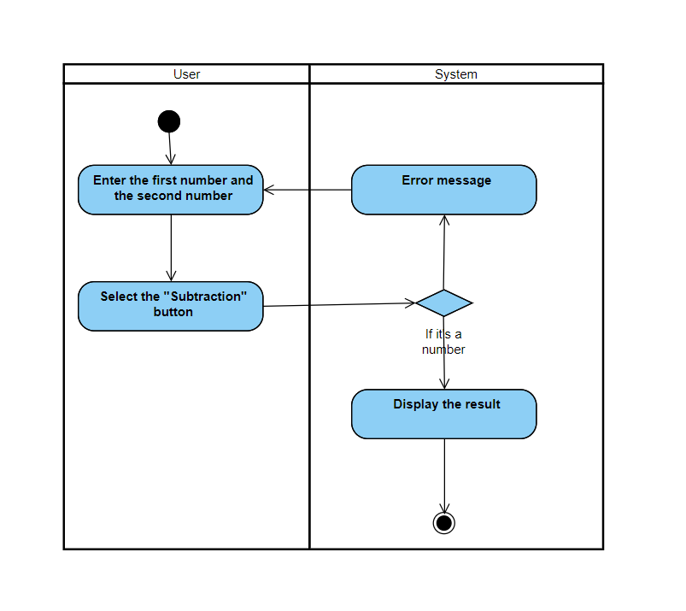

## 2.4.6.3 Multiplication

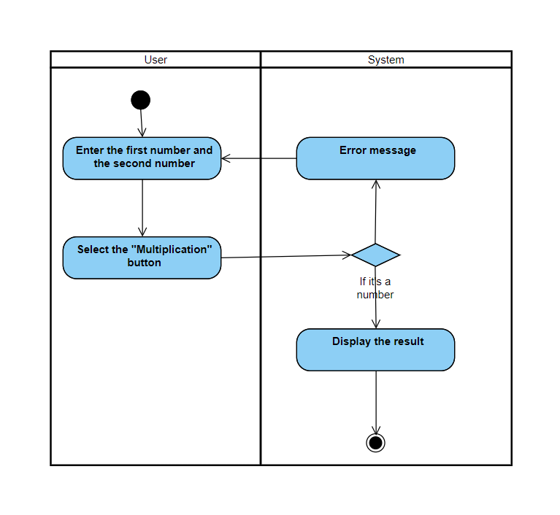

## 2.4.6.4 Div

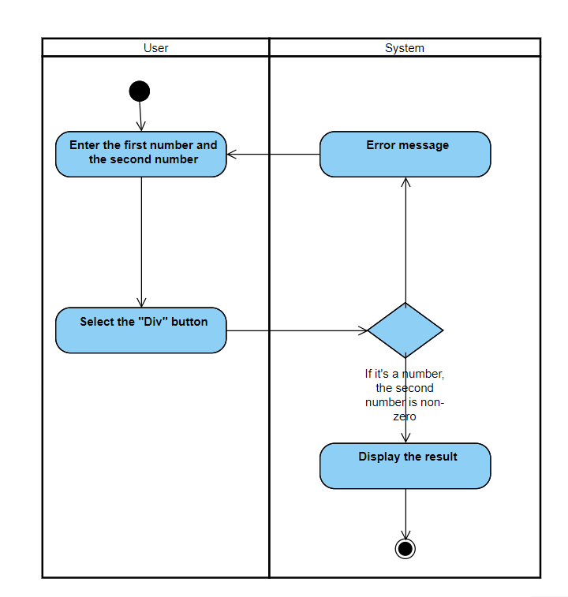

## 2.4.6.5 Mod

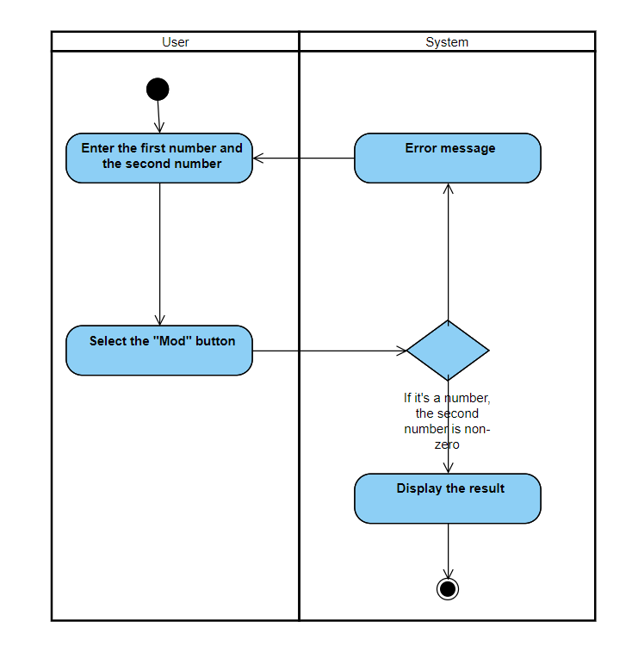

## 2.4.6.6 AC

